Sample 1

International Baccalaureate

Diploma Programme

Computer Science

B1 & B2 – Scenario-Based Practical Examination
Time allowed: 2 hours
Total marks: 100
Scenario
A secondary school is developing a Student Performance Management System.
The system will store student data, process assessment scores, generate results, and support decision-making for academic progression.
You are part of the development team responsible for designing and implementing components of this system.
Answer ALL questions with reference to the scenario.
Section A: Computational Thinking (B1)
[15 marks]

Question 1
The school wants to ensure the system is developed efficiently.
a) Decompose the system into four logical sub-systems.
b) For each sub-system, identify its inputs and outputs.
c) Explain how decomposition improves scalability and maintenance.
[6 marks]
Question 2
The system stores the following data:
StudentID, Name, Age, Address, AttendancePercentage, ExamScore
a) Identify which data should be abstracted when calculating final performance.
b) Justify your choice with reference to system efficiency.
[4 marks]
Question 3
Design an algorithm for the system that:
- accepts three assessment scores
- calculates the average score
- outputs "Pass" if the average is ≥ 50, otherwise "Fail"
Use structured pseudocode.
[5 marks]
Section B: Programming Fundamentals (B2.1)
[25 marks]

Question 4: Numeric Data Types
The system processes both whole numbers and decimal values.
a) Write code to store:
- a student’s age
- a subject average (decimal)
- a Boolean value indicating eligibility
b) Perform a calculation to update the student’s average.
c) Explain one error that could occur if an inappropriate data type is used.
[6 marks]
Question 5: String Operations
Student names are stored as strings.
a) Write code to extract the first five characters of a student’s name.
b) Modify the name by replacing spaces with underscores.
c) Display the length of the modified name.
[6 marks]
Question 6: Exception Handling
The system must handle incorrect user input.
a) Write a program that prevents the system from crashing when non-numeric input is entered for a score.
b) Explain the role of a finally block in ensuring program stability.
[5 marks]
Question 7: Debugging
A calculation module produces incorrect averages.
a) Use a trace table to locate the logic error.
b) Correct the error.
c) Identify the debugging technique used.
[8 marks]
Section C: Arrays & Lists (B2.2)
[15 marks]

Question 8
The system stores multiple exam scores for each student.
a) Create a 1D list or array to store five exam scores.
b) Traverse the structure to calculate and display the average.
c) Modify the program to find the highest score.
[7 marks]
Question 9
The system must store scores for multiple subjects and students.
a) Create a 2D array or list to store marks for three students across three subjects.
b) Display the data in a tabular format.
c) Explain one benefit of using a 2D structure in this context.
[8 marks]
Section D: Control Structures (B2.3)
[20 marks]

Question 10: Selection
Eligibility rules:
- Exam score ≥ 50
- Attendance ≥ 75%
Write a program that outputs "Eligible" or "Not Eligible" using relational and Boolean operators.
[10 marks]
Question 11: Iteration
The system needs to repeatedly process data.
a) Write a counted loop that displays student numbers from 1 to 20.
b) Write a conditional loop that continues accepting scores until "stop" is entered.
c) Explain how infinite loops can occur and how they can be prevented.
[10 marks]
Section E: Functions & Modularization (B2.3)
[10 marks]

Question 12
To improve maintainability:
a) Write a function that accepts two scores and returns the higher value.
b) Redesign a program by splitting it into three meaningful functions.
c) Explain the difference between local and global scope within the system.
[10 marks]
Section F: Algorithms & Efficiency (B2.4)
[15 marks]

Question 13: Search Algorithms
The system searches for a student ID in a sorted list.
a) Write pseudocode for a linear search.
b) Write pseudocode for a binary search.
c) Trace both searches using the same dataset.
d) Identify which search is more efficient and justify your answer.
[8 marks]
Question 14: Big O Notation
The system must scale to thousands of students.
a) Determine the time complexity of a single loop.
b) Determine the time complexity of a nested loop.
c) Explain how input size impacts performance.
[7 marks]
Section G: Recursion (HL Only)
[5 marks]

Question 15 (HL)
The system uses recursion to calculate factorial-based statistics.
a) Write a recursive algorithm to calculate the factorial of a number.
b) Identify the base case and recursive case.
c) Trace the recursive calls.
[5 marks]

B.2.1.2
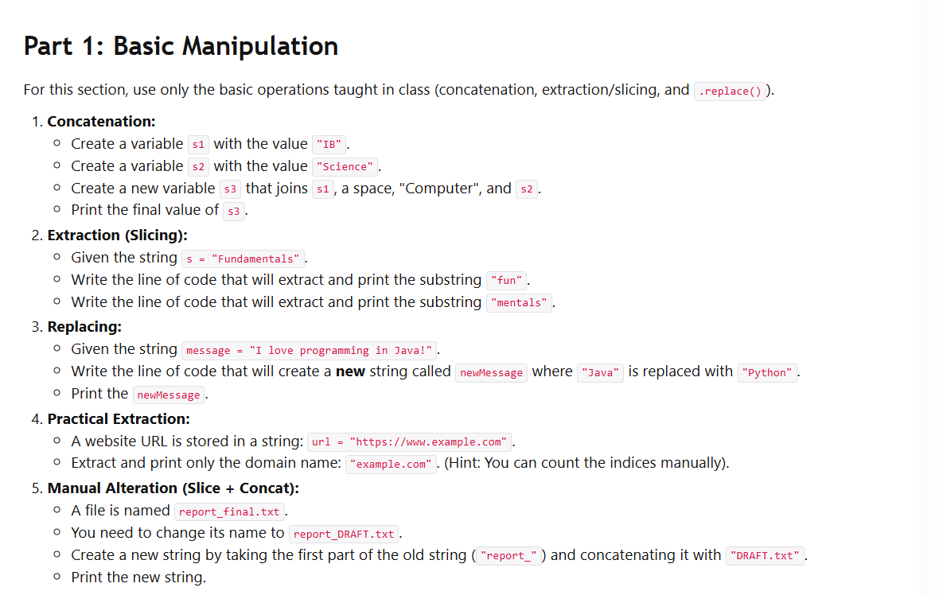
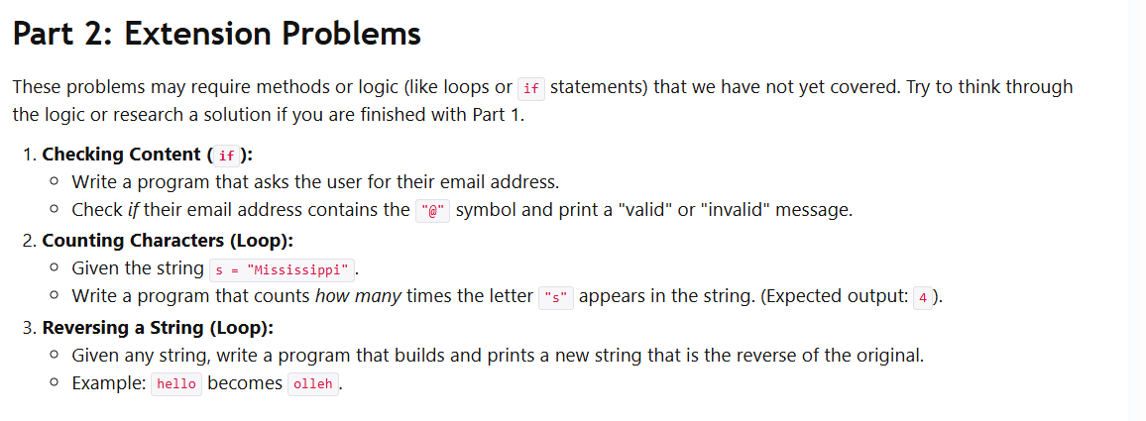

B.2.1.1

Python Version
Task 1: Basic Variable Declaration and Assignment
Create a variable named age and assign your age to it.
Create a variable named name and assign your name to it.
Print the values of age and name.

#Your code here....
Task 2: Data Type Conversion
Create a variable named price and assign a value with decimals (e.g., 19.99) to it.
Convert price to an integer and store it in a new variable named integer_price.
Print both price and integer_price.

#Your code here......
Task 3: Global and Local Variables
Create a global variable named global_count and initialize it to 0.
Define a function named increment_count that increments global_count by 1.
Call increment_count twice from outside the function.
Print the value of global_count.

#Your code here

B.2.1.1 -Trace
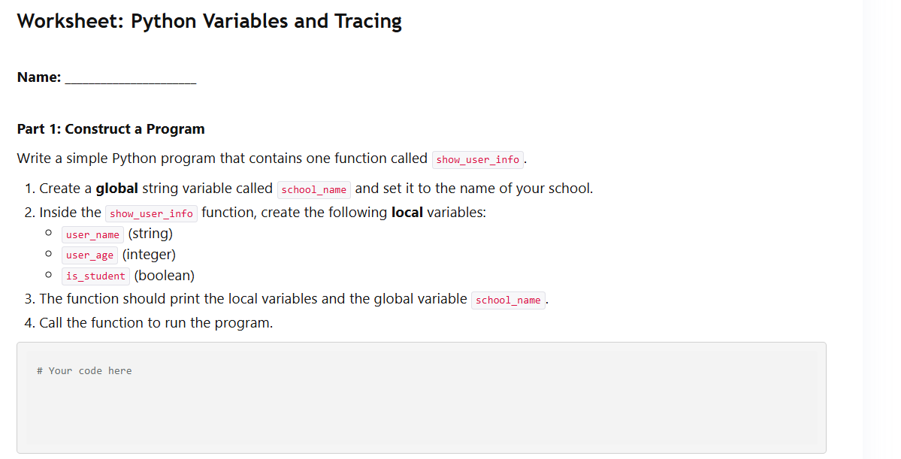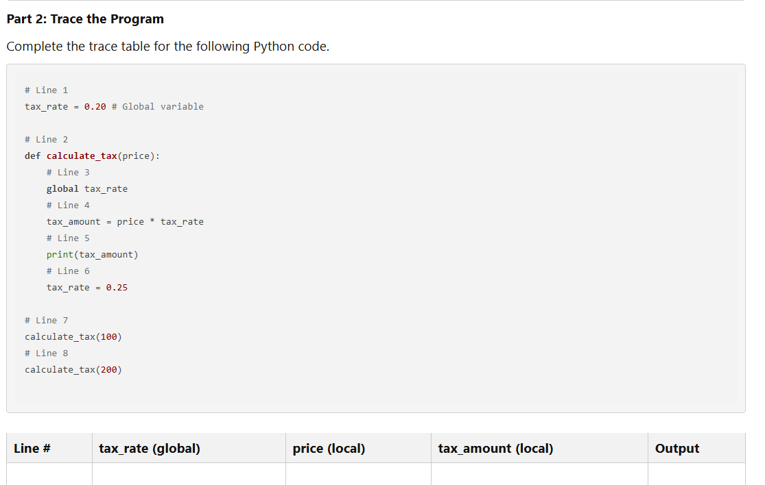

Substring Manipulation
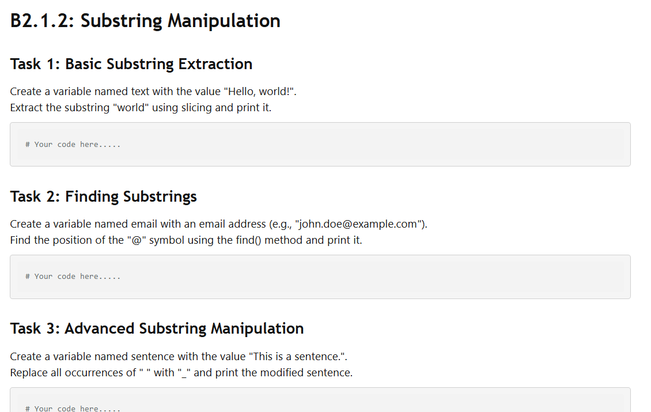

Handling
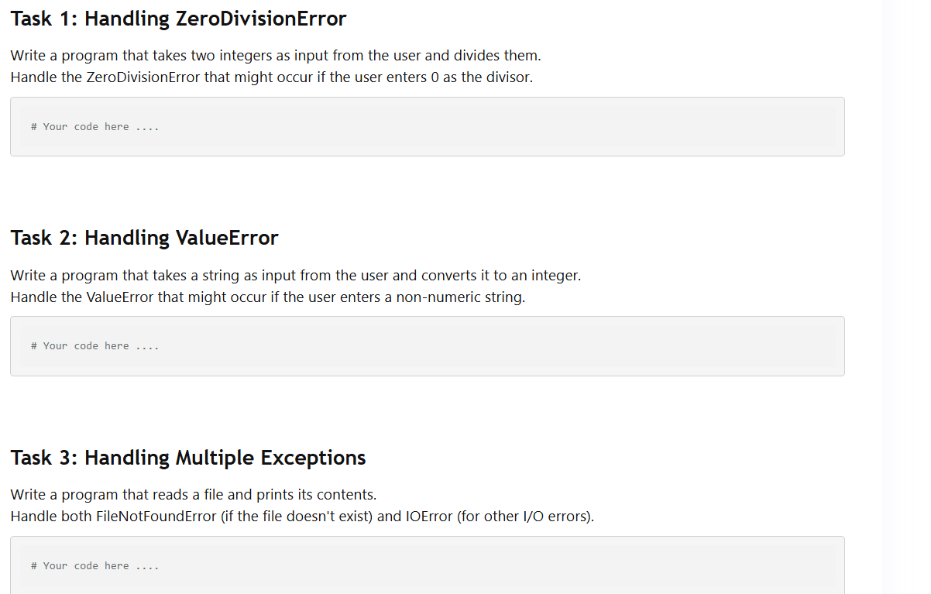

Lists
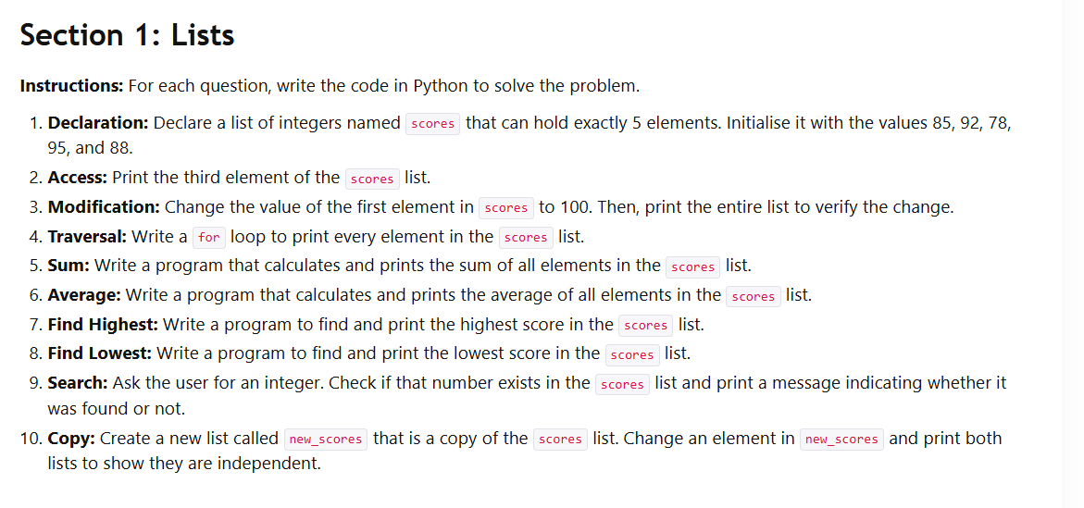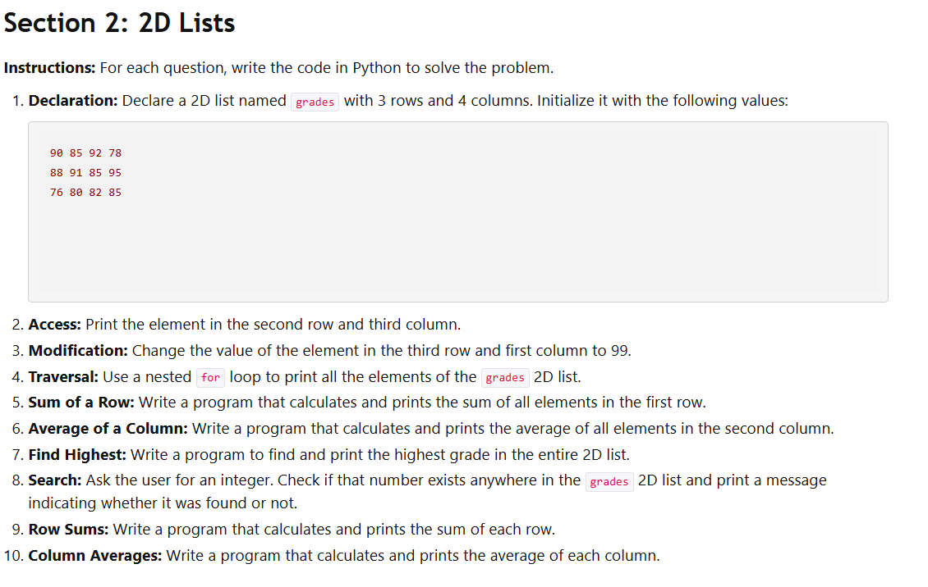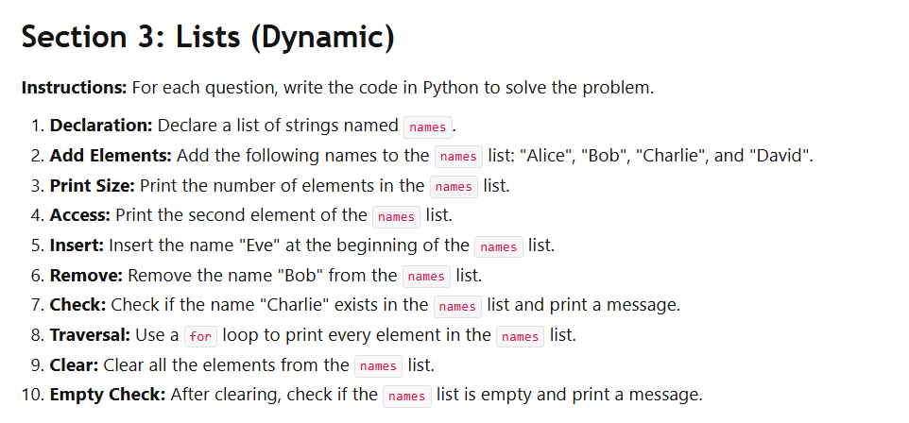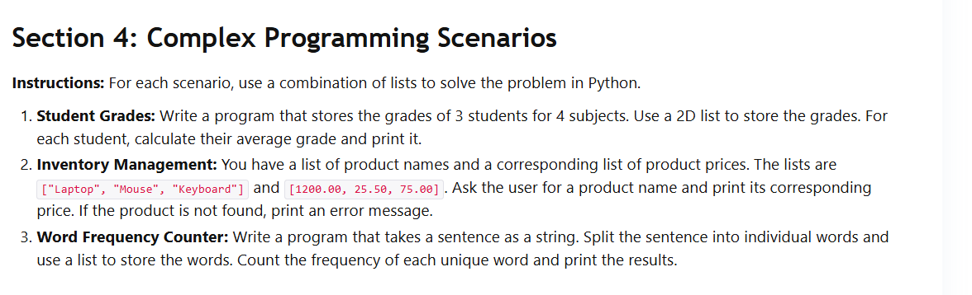

Code Analysis-Debugging

Activity 1: Code Analysis - Python
Instructions: Analyse the following Python code snippets and predict the output. If there is an error, explain why.

Snippet 1:
x = 5
y = 10
sum = x + y
print("The sum is:", sum)
Predicted Output:

Snippet 2:
print("The product is:", 5 * 10)
Predicted Output:

Snippet 3:
a = 10
b = 5
print("The difference is:", a - b)
Predicted Output:

Snippet 4:
i = 0
while i < 5:
print("Iteration:", i)
Predicted Output:

Snippet 5:
num = 10
if num > 5:
print("Number is greater than 5")
print("Number is:", num)
Predicted Output:

Activity 2: Debugging Challenge - Python
Instructions: The following Python code snippets contain errors. Identify the errors and correct the code to produce the desired output.

Snippet 1:
while True:
print("This is an infinite loop!")

Desired Output: The loop should terminate after printing the message 5 times.

Corrected Code:

Snippet 2:
x = 5
y = "10"
print("The sum is:", x + y)

Desired Output: The sum is: 15

Corrected Code:

Snippet 3:
for i in range(1, 11):
if i % 2 == 0:
print(i, "is even.")
print(i, "is odd.") # This line is always executed
Desired Output: Print only whether a number is even or odd, not both.

Corrected Code:

Iterations

Selection Structures - Python
Name: _________________________

Instructions: Write Python code to solve the following problems.

if Statements
Write a program that takes an integer as input and prints "Positive" if the number is greater than 0.
Write a program that takes an integer as input and prints "Even" if the number is divisible by 2.
Write a program that takes a character as input and prints "Vowel" if the character is 'a', 'e', 'i', 'o', or 'u' (or their uppercase equivalents).
Write a program that takes a string as input and prints "Empty" if the string has no characters.
Write a program that takes two integers as input and prints "Equal" if the numbers are the same.
else Statements
Modify problem 1 (in the if statements section) to also print "Negative" if the number is less than 0.
Modify problem 2 (in the if statements section) to also print "Odd" if the number is not divisible by 2.
Modify problem 3 (in the if statements section) to also print "Consonant" if the character is not a vowel.
Modify problem 4 (in the if statements section) to also print the string itself if it's not empty.
Modify problem 5 (in the if statements section) to also print "Not Equal" if the numbers are different.
Write a program that takes an integer representing an age as input. If the age is 18 or older, print "You can vote". Otherwise, print "You cannot vote yet".
Write a program that takes a number representing a temperature in Celsius. If the temperature is below 0, print "Freezing". Otherwise, print "Not freezing".
Write a program that takes a boolean value representing whether it is raining. If it is raining, print "Take an umbrella". Otherwise, print "No need for an umbrella".
Write a program that takes a string representing a password. If the password is "secret", print "Access granted". Otherwise, print "Incorrect password".
Write a program that takes an integer representing the day of the week (1 for Monday, 2 for Tuesday, etc.). If the day is Saturday or Sunday, print "Weekend". Otherwise, print "Weekday".
elif Statements
Write a program that takes an integer grade as input and prints the corresponding letter grade:
90 or above: A
80-89: B
70-79: C
60-69: D
Below 60: F
Write a program that takes a number representing a person's height in centimetres.
If the height is 180 or more, print "Tall".
If the height is between 160 and 179, print "Average".
Otherwise, print "Short".
Write a program that takes an integer representing the number of hours worked in a week.
If the hours are more than 40, calculate overtime pay at 1.5 times the regular rate (assume a rate of $10/hour).
Otherwise, calculate regular pay.
Write a program that takes a string representing a fruit.
If the fruit is "apple", print "red".
If the fruit is "banana", print "yellow".
If the fruit is "orange", print "orange".
Otherwise, print "unknown".
Write a program that takes an integer representing a month (1 for January, 2 for February, etc.). Print the season based on the month:
December, January, February: Winter
March, April, May: Spring
June, July, August: Summer
September, October, November: Fall
Write a program to determine the shipping cost based on the weight of a package.
If the weight is less than or equal to 1kg, the shipping cost is $5.
If the weight is between 1kg and 5kg, the shipping cost is $10.
If the weight is more than 5kg, the shipping cost is $20.
Write a program to check if a triangle is equilateral, isosceles, or scalene. Take three integers as input representing the lengths of the sides.
Write a program to calculate the discount on a purchase.
If the purchase amount is greater than $100, apply a 10% discount.
If the purchase amount is greater than $50, apply a 5% discount.
Otherwise, no discount is applied.
Write a program that takes an integer representing a person's age and a boolean value representing whether they have a driver's license.
If the person is 16 or older and has a driver's license, print "You can drive".
Otherwise, print "You cannot drive".
Write a program that takes a character representing a letter grade ('A', 'B', 'C', 'D', or 'F') and prints the corresponding GPA:
A: 4.0
B: 3.0
C: 2.0
D: 1.0
F: 0.0
Nested if Statements
Write a program that takes an integer representing a person's age and their height in centimetres.
If the person is 18 or older, check their height. If their height is 170cm or more, print "You are tall". Otherwise, print "You are of average height".
If the person is younger than 18, print "You are still growing".
Write a program to determine a movie ticket price. Ask the user for their age (integer) and the time of day ("matinee" or "evening").
If the age is 18 or older (adult), the price is $10 for a matinee and $15 for an evening show.
If the age is under 18 (child), the price is $7 for a matinee and $10 for an evening show.
Print the final ticket price.
Write a program for a simple vending machine. First, ask the user to select a category: "food" or "drink".
If the user selects "food", ask them to choose between "chips" ($1.50) or "candy" ($1.00). Print their choice and the price.
If the user selects "drink", ask them to choose between "soda" ($1.25) or "water" ($0.75). Print their choice and the price.
Handle invalid inputs for both categories and items.
Write a program that takes a string representing a username and a string representing a password.

If the username is "admin", check the password. If the password is "password123", print "Access granted". If not, print "Incorrect password".
If the username is not "admin", print "Invalid username".
Write a program that takes an integer representing a number.
If the number is positive, check if it's even or odd. If it's even, print "Positive and even". If it's odd, print "Positive and odd".
If the number is negative, print "Negative number".
If the number is zero, print "Zero".

Loops

Worksheet: Looping Structures - Python
Name: _________________________

Instructions: Write Python code to solve the following problems.

for Loop
Print the numbers from 1 to 10.
Print the even numbers from 1 to 20.
Calculate the sum of numbers from 1 to 100.
Print the characters in the string "Hello, world!".
Print the first 10 elements of the Fibonacci sequence (starting with 0 and 1).
Print a triangle pattern of stars (e.g., 5 rows with 1 star in the first row, 2 in the second, and so on).
Print the numbers from 10 to 1 in reverse order.
Print every third number from 3 to 30.
Calculate the factorial of a given number (e.g., 5! = 5 * 4 * 3 * 2 * 1).
Print the following pattern:
1
12
123
1234
12345

while Loop
Take integer input from the user until they enter a negative number.
Keep asking the user for a password until they enter the correct one ("secret").
Generate random numbers between 1 and 100 until a number greater than 90 is generated.
Calculate the sum of even numbers entered by the user until they enter 0.
Simulate a simple number guessing game where the user has to guess a randomly generated number between 1 and 100.
Ask the user for two numbers and print all the numbers between them (inclusive).
Print the first 10 prime numbers.
Take a string as input and count the number of vowels in it.
Take a positive integer as input and check if it is a palindrome (reads the same backward as forward).
Print the following pattern: ```

Modularizing
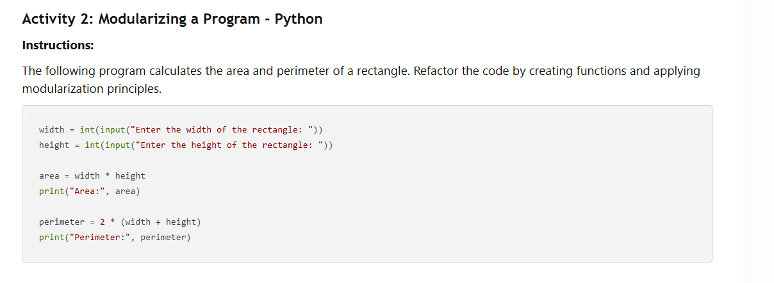

Algorithms
Instructions: Analyse the following Python code snippets or algorithm descriptions. For each, determine the time complexity and space complexity using Big O notation. Briefly explain your reasoning.

Part 1: Code Snippets
1.

def print_first_element(my_list):
"""Prints the first element of a list."""
print(my_list[0])
2.

def print_all_elements(my_list):
"""Prints all elements in a list."""
for element in my_list:
print(element)
3.

def find_sum(my_list):
"""Calculates the sum of all elements in a list."""
total = 0
for element in my_list:
total = total + element
return total
4.

def print_pairs(my_list):
"""Prints all possible pairs of elements in a list."""
for i in range(len(my_list)):
for j in range(len(my_list)):
print(my_list[i], my_list[j])
5.

def contains_value(my_list, value):
"""Checks if a sorted list contains a given value using binary search."""
low = 0
high = len(my_list) - 1
while low <= high:
mid = (low + high) // 2
if my_list[mid] == value:
return True
elif my_list[mid] < value:
low = mid + 1
else:
high = mid - 1
return False

Part 2: Algorithm Descriptions
An algorithm that checks if a number is even or odd.
An algorithm that finds the smallest element in a sorted list.
An algorithm that calculates the factorial of a number (n!).
An algorithm that reverses the order of elements in a list.
An algorithm that checks if a string is a palindrome (reads the same backward as forward).
An algorithm that generates all possible subsets of a set.
An algorithm that finds the closest pair of points in a set of points in a 2D plane. (This is a classic computational geometry problem.)
Part 3: Challenge Questions
def mystery_function(my_list):
"""Performs a mysterious operation."""
i = 0
j = len(my_list) - 1
while i < j:
temp = my_list[i]
my_list[i] = my_list[j]
my_list[j] = temp
i = i + 1
j = j - 1
An algorithm that finds the second-largest element in an unsorted list.
An algorithm that calculates the sum of all the numbers in a 2D array (a list of lists).
An algorithm that efficiently searches for a specific value in a sorted tree data structure (you'll learn more about trees later!).
An algorithm that finds all the prime numbers less than a given number 'n'.
Part 4: Scalability and Algorithm Choice
You must write a program to process millions of financial transactions in real-time. Would you prefer an algorithm with O(n2) time complexity or O(n log n) time complexity? Why?
You are designing a mobile app that needs to perform calculations on a small set of user-provided data. Does the space complexity of the algorithm matter as much in this scenario compared to the financial transaction processing scenario in question 18? Explain.
Describe a situation where you might prioritise using an algorithm with O(n) time complexity over an algorithm with O(log n) time complexity, even though O(log n) is generally more efficient.
Why is it important to consider the scalability of an algorithm, especially in applications that deal with large and growing datasets?
Imagine you are working with a limited amount of memory. How might this constraint influence your choice of algorithm?
Bonus:
For some of the code snippets or algorithm descriptions, can you think of different ways to achieve the same result with a different Big O complexity?
Research and find examples of real-world applications where specific Big O notations are crucial for performance.

Binary and Linear
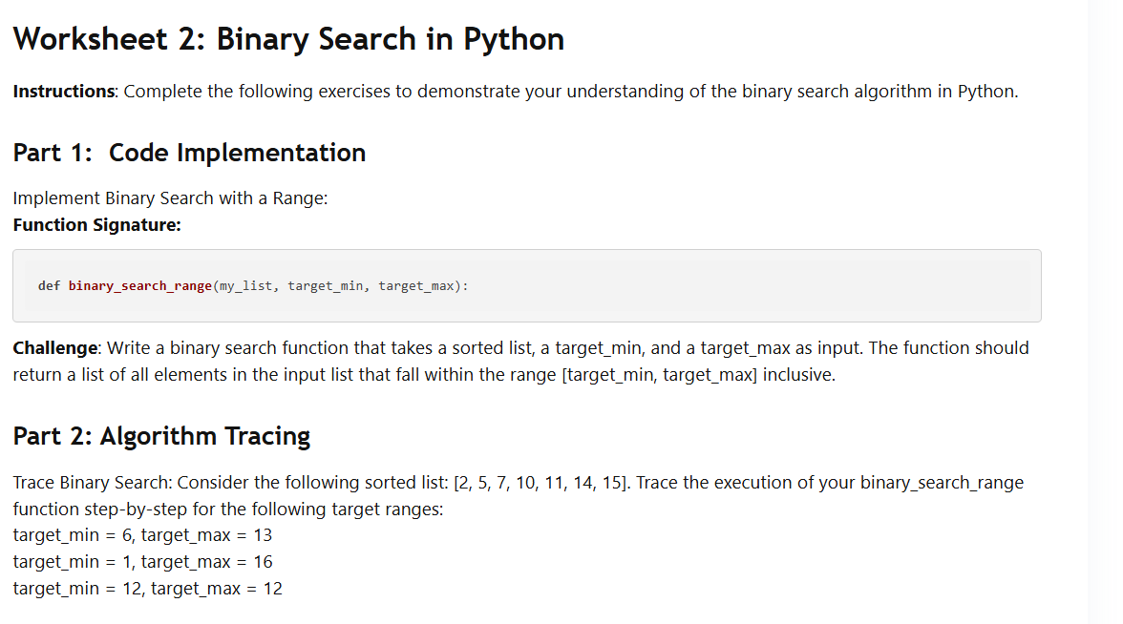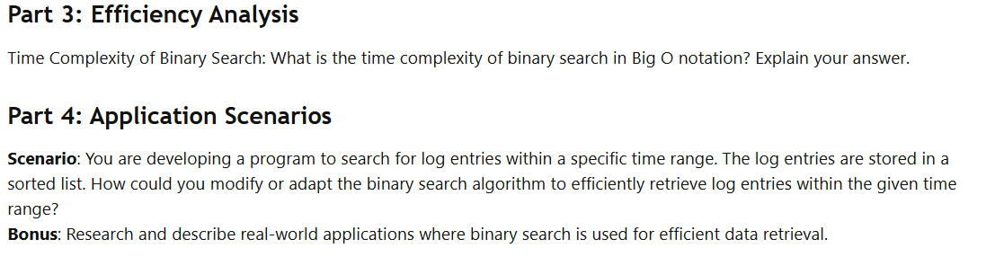

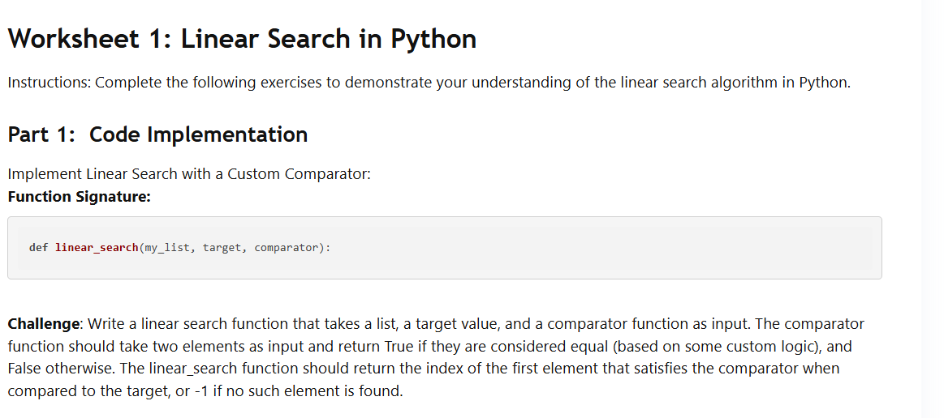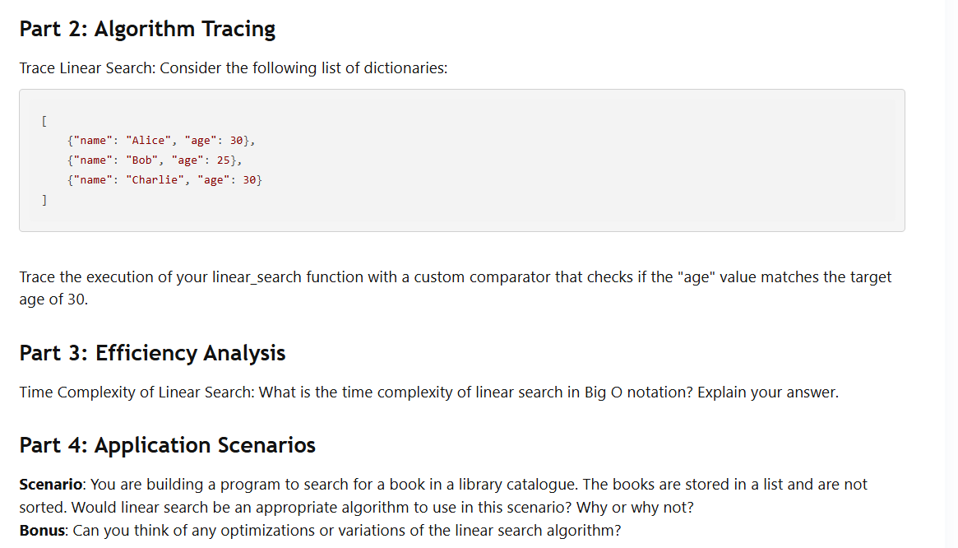

Sorting
Bubble Sort

Key Questions:
Explain how the swapping of adjacent elements in bubble sort leads to a sorted list.
Why is the inner loop of the bubble sort algorithm shortened in each iteration of the outer loop?
How does bubble sort's performance change if the input list is nearly sorted?
What are some advantages and disadvantages of using bubble sort compared to other sorting algorithms?
Can you explain why bubble sort is considered a stable sorting algorithm?

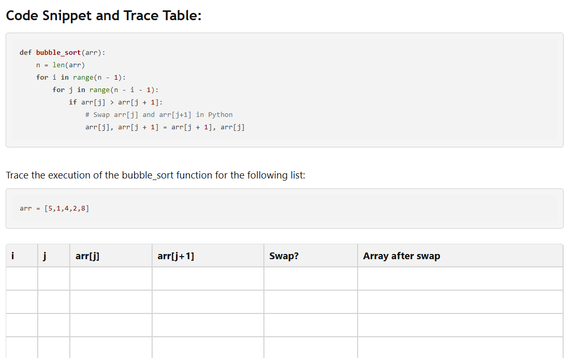

Recursion
Question 1

(a) The iterative method iter_d(n) is shown, which prints numbers to the console:

def iter_d(n):
while n > 0:
print(n)
n = n - 1
(i) State the output printed by the call iter_d(4). [1]

(ii) Construct the recursive method recur_d(n) that performs the same function. [3]

Question 2

(a) The iterative method iter_e(s, n) is shown, which repeats a string:

def iter_e(s, n):
result = ""
while n > 0:
result = result + s
n = n - 1
return result
(i) State the value returned by the call iter_e("Go", 3). [1]

(ii) Construct the recursive method recur_e(s, n) that performs the same function. [3]

Question 3

(a) The iterative method iter_f(n) is shown:

def iter_f(n):
total = 0
while n > 0:
total = total + (2 * n)
n = n - 1
return total
(i) State the value returned by the call iter_f(4). [1]

(ii) Construct the recursive method recur_f(n) that performs the same function. [3]

